Overview

The Campbell Muscle Lab has two pH meters. The main lab/office has a Mettler Toledo SevenMulti and the mechanics room has a Mettler Toledo Seven GoDuo Pro. The Seven GoPro device also has a dissolved oxygen sensor. This pH meter is found in Mn-507. The Protocol for the Mettler pH meter is denoted #1.

The lab has a Fisher Scientific AB150 pH/mV with a accuTupH pH meter the protocol for alibration/maintenance/use of this pH meter is denoted #2. The manual from the supplier can be found here: http://www.masterflex.com/assets/Manual_pdfs/59331-74.pdf

Before using pH meters: watch the videos on this page: http://www.electrodes.net/en/goodies - especially "3) Measure correctly" "4) Clean the electrode" and "5) Electrode storage".

#1 Specific descriptions and instructions for the Mettler pH probes.

The SevenMulti device currently has an InLab Expert Pro ISM probe. The probe has a plastic shaft and is a polymeric electrode. The probe is more durable and requires minimal maintenance.

The Seven GoDuo Pro device currently has a Mettler Toledo InLab Routine Pro ISM probe. The probe has a glass shaft and a standard Ag/AgCl electrode. Because of the nature of the electrode, you need to un-cover a port before use. The port must be re-sealed after use to prevent evaporation.

Additional resources

Need more help?

Check the resources, and then see Ken

Main content

**Specific Descriptions and Instructions for the Meter pH Probes**

The SevenMulti device currently has an InLab Expert Pro ISM probe. The probe has a plastic shaft and is a polymeric electrode. The probe is more durable and requires minimal maintenance.

The Seven GoDuo Pro device currently has a Mettler Toledo InLab Routine Pro ISM probe. The probe has a glass shaft and a standard Ag/AgCl electrode. Because of the nature of the electrode, you need to un-cover a port before use. The port must be re-sealed after use to prevent evaporation.

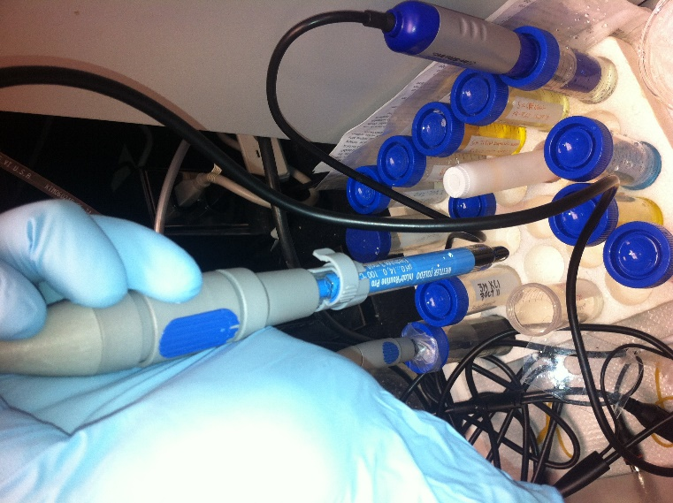

Ready For Use

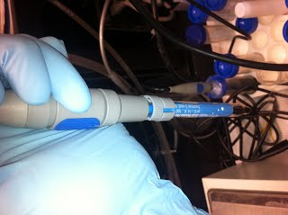

Ready for Storage

The high potassium solution within the probe must be replaced regularly. See the bottom of the page for details. Also: Because it is glass, you should be very careful not to hit or nick the probe on anything.

**Part 1: General Use and Maintenance**

1. Always check to see how long the storage and calibration solutions have been used.  Replace all solutions at least once every 3 months.  If heavy use has occurred, once every month is recommended.
   1. The pH sensors are all stored in a **pH Electrode** **solution** in a 50mL Falcon tube with a hole drilled in the top.  20 mL of each of the three (pH 4.0, 7.0, and 10.0) solutions are also held in 50mL Falcon tubes.

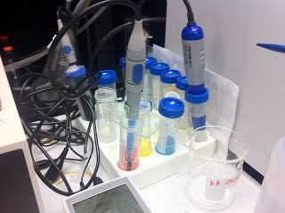

One reason to change the solution is cross-contamination. Each time you use your system, a drop of water may contaminate the solution. Solutions may contaminate each other, if you do not do a good wash. In practice, the change in pH should be small, but it can build up. Another reason to change the solutions is evaporation.

1. Always calibrate your sensor at least once for each day of use. (These instructions work with both meters.)

To calibrate:

* 1. Take the pH electrode out of the storage solution and rinse with DI H2O.
  2. In general, you should not touch the probe with anything (even a kimwipe). a gentle flick will usually get most of the water/solution off the tip. Be careful where you are flicking so you don't hit the probe on anything or drop it.
  3. Place the electrode into the pH 4.0 calibration solution and hit the "Calibrate" or "Cal" button on the pH meter.
  4. There will be a blinking "A" until the meter reaches a steady state.
  5. You should stir the solution every few moments while it is reading. This will both speed up the measurement and help calibration accuracy.
  6. You can override this or any reading by pressing the "Read" button on the pH meter. The blinking "A" will turn into an "M" with what looks like a square-root sign above it.
  7. When the "A" stops blinking and a square-root sign appears over it, the reading is done. Remove the probe and rinse it with DI H2O. Place the electrode into the pH 7.0 calibration solution and repeat the steps above. When this is complete, repeat the steps for a pH 10.0 calibration solution. When that is complete, rinse the probe again and place it in the pH Electrode Storage solution.
  8. After the pH 10.0 calibration, the calibration parameters will be shown. Find the button under the "SAVE" point and save this calibration.
  9. Check calibration by placing sensor in pH 7.0 and pressing "Read". If it is not within 0.02, then repeat the calibration.

1. Make pH readings.

* DO NOT allow the pH meter to touch/sit on the bottom of the beaker, this will prevent damage and allow solution to move across the sensor better. Use the stand in the main lab, or plastic in the mechanics room.
* Wait for the sensor to finish reading before adding more acid/base when pHing. It sometimes has farther to go than you think.
* When removing from experimental solutions (not calibrating) rinse the probe into the solution. In fact, you should always rinse off the probe when you take it out of one solution and place it into another.
* If you will use your solution at a specific temperature, make sure you pH at that temperature. Tyrode's solution, for example, drops from pH=7.3 to pH=7.0 when temperature is raised from 25oC to 37oC.

1. Always rinse off the pH meter and store it in pH Electrode solution* when not in use. When removing from experimental solutions (not calibrating) rinse the probe and place it in the solution.

Always rinse off the previous solution before placing it into the storage solution.

*If you run out of pH electrode solution, pH 4.0 calibration solution can be used. But in practice, you should always re-order the solution when it gets low so you never run out of pH electrode solution.

**Part 2: Dissolved Oxygen Sensor**

The Dissolved Oxygen Sensor cap (OptiOx, Mettler Toledo 53143164) needs to be replaced yearly.  Follow the instructions included with the cap.

To Calibrate:

* Remove the white (not red) cap on the Mettler Toledo Calibration Tube OptiOx.
* Sightly wet the yellow sponge with ddH2O.  After some water soaks into the sponge, you can flick the tube to remove any standing water.  The sponge does not need much liquid.
* Rinse the end of the OptiOx probe and place it so that the blue sensor head sits on the wet sponge.
* Change the Mode of the Mettler Toledo SevenGo Pro Duo device to the O2 sensing mode.
* Press on calibrate.  The system screen will change.  Press the Save button.  The sensor is now calibrated.

To Measure Dissolved Oxygen

* Rinse the end of the OptiOx probe with ddH2O.
* Place the probe into the solution of interest.  Try to keep the probe off the bottom of the beaker, especially since the bottom of the probe needs to interact with the solution.
* Wait for the sensor to finish measuring.
* Remove the probe and rinse it off, then return it into its storage falcon tube.  The tube should have ~30mL ddH2O when empty.

**Part 3: Specific Maintenance of the In Lab Routine Glass pH Probe**

* Replacing the internal 3M KCl solution.
  + The probe is filled using Mettler Toledo part # 51 343 180, which is available via Fisher in 25 mL bottles.
  + To remove the liquid within the chamber, open the access port, invert the probe and hold it with the access port slightly down.

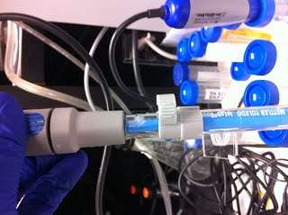

* Using a 200mL pipette or small bub pipette, drain the liquid within the probe. Note: Inversion or shaking of the probe may be required to remove all liquid.

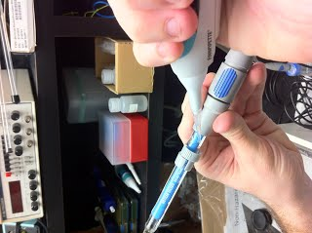

* Wash out the solution by filling the probe with water then draining (as above) three times (3x).
* Refill the probe with the 3M KCl solution, and drain at least once (twice recommended).

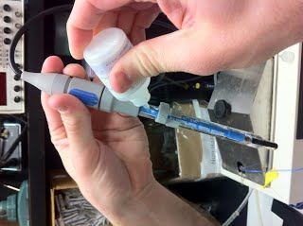

* Refill the probe a final time and recap the access port.  Only fill up to the filling hole.

**Specific Descriptions and Instructions for Fisher Scientific Probe**

The Fisher Scientific pH probe is a typical Ag/Cl electrode with glass shaft. Similar to the Mettler probe, there is an oxygen port on the side that needs to be uncovered for optimal use. This is covered by the purple plastic rotating cover (cap ring). This must be turned clockwise until the port is left uncovered. When Storing be sure to re-cover this port in order to ensure the electrode doesn't dry out.

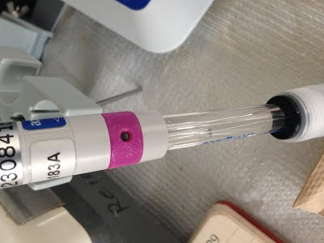

Ready for Use

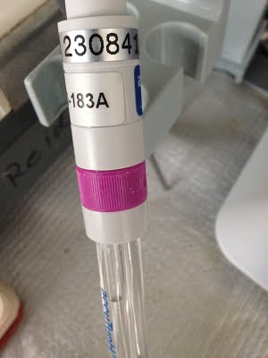

Ready to Store

The high potassium solution within the probe must be replaced regularly. See the bottom of the page for details. Also: Because it is glass, you should be very careful not to hit or nick the probe on anything.

**Part 1: General Use and Maintenance**

1. Always check to see how long the storage and calibration solutions have been used. Replace all solutions at least once every 3 months. If heavy use has occurred, once every month is recommended.

The pH sensors are all stored in a pH Electrode solution which is from the manufacturer. This storage solution is a 50:50 mix of 4M KCl and pH 4 Buffer. 20 mL of each of the three (pH 4.0, 7.0, and 10.0) solutions are also held in 50mL Falcon tubes (shown below) These are the solutions used for calibration which will be described below.

1. Always calibrate your sensor at least once for each day of use. (These instructions work with both meters.)
   1. To calibrate:
      1. Take the pH electrode out of the storage solution and rinse with DI H2O.
      2. In general, you should not touch the probe with anything (even a kimwipe). a gentle flick will usually get most of the water/solution off the tip. Be careful where you are flicking so you don't hit the probe on anything or drop it.
      3. Place the electrode into the pH 4.0 calibration solution and wait for the reading to stabilize. The reading should be within +-0.05 of the calibration solution value.
      4. This should be repeated for the pH 7 and pH 10 calibration solutions.
      5. If you need more information refer to the manual: http://www.masterflex.com/assets/Manual_pdfs/59331-74.pdf
2. Make pH Readings

* DO NOT allow the pH meter to touch/sit on the bottom of the beaker, this will prevent damage and allow solution to move across the sensor better. Use the stand in the main lab, or plastic in the mechanics room.
* Wait for the sensor to finish reading before adding more acid/base when pHing. It sometimes has farther to go than you think.
* When removing from experimental solutions (not calibrating) rinse the probe into the solution. In fact, you should always rinse off the probe when you take it out of one solution and place it into another.
* If you will use your solution at a specific temperature, make sure you pH at that temperature. Tyrode's solution, for example, drops from pH=7.3 to pH=7.0 when temperature is raised from 25oC to 37oC.

1. Always rinse off the pH meter and store it in pH Electrode solution* when not in use.  When removing from experimental solutions (not calibrating) rinse the probe and place it in the solution.
   1. Always rinse off the previous solution before placing it into the storage solution

*If you run out of pH electrode solution, pH 4.0 calibration solution can be used. But in practice, you should always re-order the solution when it gets low so you never run out of pH electrode solution.